

**MNGT202/502**

**Project Management 2021-22**

**Liverpool Waters Project**

**Project Information**

**Handbook**

Academic Guide: Dr Matt Murphy

Room 168b Walker Building

School of Engineering

University of Liverpool

Liverpool L69 3GH

Table of Contents

1. Introduction 3

1.1. Project Brief 3

1.2. Learning Objectives 5

2. Project Descriptions 6

2.1 Residential Properties 6

2.2 Business Offices 7

2.3 Cruise Liner Terminal 8

2.4 Isle of Man Ferry Terminal 9

2.5 Five Star Hotels 11

2.6 Bars & Restaurants 12

2.7 World Class Sports Stadium 13

2.8 Retail Park 14

2.9 Sports & Leisure Centre 15

2.10 Supermarket 16

3. Further Information 18

# Introduction

## Project Brief

The project requires you and your team to analyse, plan and manage the creation of Liverpool Waters: a project that will transform the city’s northern docks, regenerating a 60-hectare site to create a world-class, mixed-use waterfront quarter in central Liverpool. Your project team is employed by Liver Construction Ltd. and already have been assigned a specific construction task within the waterfront which **should be completed within 25 weeks**. The information provided in this pack is to be used to complete your project. (*Not all information in the pack is required; please refer only to your part of the construction within the project*.)

The project is split up into five tasks:

* Situational Analysis & Formulation of Objectives
* Work Programme Planning and Scheduling
* Critical Path Analysis
* Risk Analysis & Management
* Cost Analysis & Management

Tasks will be launched after each lecture, and full instructions, templates and upload links will be posted on VITAL.

All five tasks must be completed **as a group**.

You must have a meeting at least once every week. Agendas & Minutes from these meetings must be submitted as part of each task. It would be good practice to also post them on the VITAL file exchange for the benefit of the group.

There are formal two roles in each team: Project Manager and Secretary: you should all take a turn in each role for one or another of the tasks. The responsibilities of each role are included in the Introductory Lecture slides.

**The start date for your construction project should be 26th October 2021 and the project has a 25 week duration.** (This is in “project time frame” and not actual time)

**10 Facts about this Project**

1. Your team are running the project but you will need to recruit a specialised workforce to deliver it.
2. There is a ready supply of enthusiastic labour but most people require training and transport.
3. All raw materials, tools and equipment required are to be purchased and delivered internationally.
4. Many fixtures, fittings and specialist equipment must be purchased from other cities in the United Kingdom, Europe or North America.
5. Transport links are subjected to strikes: deliveries must be planned early and carefully managed. (Overseas deliveries only occur once a day Monday-Wednesday)
6. There is also a helicopter at your disposal for overseas deliveries for a much greater cost, but reduced transport time (Delivery takes 5 hours, available Monday - Friday).
7. Bad weather will affect all transport to the area as it is prone to flooding and strong winds as it is so close to the River Mersey. This weather will also affect the use of tall cranes and heavy construction equipment.
8. International workforce might struggle with the language barrier and will take longer to train. (International Workforce Training = 3 weeks, UK Workforce Training = 1 week)
9. Local residents and protest groups may be difficult and obstruct the building.
10. The Waterfront is largely overgrown and covered in debris from past use. Pathways, roads and infrastructure do not exist. A clean-up is required before starting the project.

## Learning Objectives

After completing this project you should have developed an understanding of, and ability to apply, the following topics:

* Define the meaning of the common terms associated with management *(Lecture 2)*
* Explain what a project is*. (Lecture 2)*
* Explain what a Project Manager is responsible for and what are their key roles*. (Lecture 2)*
* Explain and devise SMART objectives  *(Lecture 2)*
* Explain the objectives and key elements of Planning*. (Lectures 2 & 3)*
* Perform tasks associated with project management e.g. a SWOT analysis and a WBS*. (Lectures 2 & 3 and Tasks 1 & 2)*
* Identify tasks in relation to time management. E.g. Interpret Gantt charts, understand critical paths and identify slack and opportunities for crashing a project.  *(Lectures 3 & 4 and Tasks 2 & 3)*
* Explain, devise and use a risk register. *(Lecture 5 and Task 4)*
* Understand Costing basic terms *(Lecture 5)*
* Define and calculate direct, indirect, costs *(Lecture 5)*
* Define and calculate different Labour Rates *(Lecture 5)*
* Explain and use joint costing and other similar methods, e.g. Order Costing and Continuous Costing *(Lecture 5)*
* Understand how to estimated overheads and calculate their absorption*. (Lecture 6 and Task 5)*
* Explain depreciation and the different ways to calculate it *(Lecture 6 and Task 5)*
* Define and calculate fixed & variable costs  *(Lecture 6)*
* Explain and be able to use DCF, Payback and NPV *(Lecture 6)*
* Performing successfully as a member or leader of a team (Virtual tasks and meetings)
* Delivering tasks to a deadline (VP tasks)
* Communicating with fellow students (VP meetings)
* Demonstrating creativity and innovative thinking (VP tasks)
* Accessing information and expertise from a variety of sources, including academic staff (VP tasks and background research)
* Use of Microsoft Project PM software (VP tasks)
* Evaluating your own and your team members’ performance (Peer Moderation)

# 2. Project Descriptions

Your team will be managing the completion of one of ten construction projects, within a wider programme to develop the Liverpool Waterfront area. Each project is described below. Included in the description is information and data that you will need to complete the five assessed project tasks. Some additional information will be released as the module progresses. Dr Murphy will explain how and when you will need to use this data.

## 2.1 Residential Properties

To improve city living, 4 residential properties will be built totalling to over 1000 new apartments. Ideal for professionals living with some of the best facilities in the city, receiving hotel style services. Out of the 4 new properties, you will focus on building The Lexington, due to become an icon of the city’s skyline. The Lexington should be a 34 storey building with 304 apartments focused on the private rented sector. The height should be 112m and the base of the building should be 25m x 20m.

You should factor the following approximated time scales into your project planning:

* It takes **2 weeks** to excavate the foundations.
* It takes **3 weeks** to lay the concrete.
* It takes **3.5 weeks** to construct the walls.
* It takes **1 week** to add the roof.
* It takes **3 weeks** to add the windows.
* It takes **2.5 weeks** to do the plumbing for the building.
* It takes **2 weeks** to install electrical supply.
* It takes **1 week** to add the insulation to the building.
* It takes **2 weeks** to decorate the building.
* Adding the internal furniture and features, such as a property kitchens and bathrooms, will take **4 weeks** in total.
* Adding the elevators to the building takes **1 week** in total.

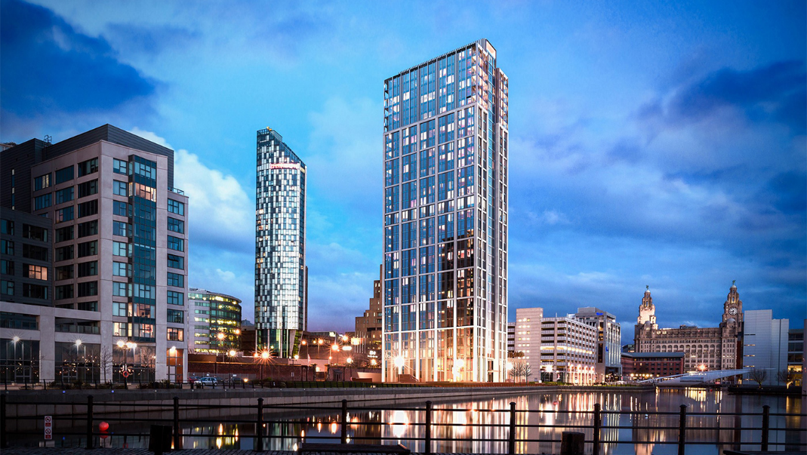

Figure 1: The Lexington building

## 2.2 Business Offices

Over 2,500 people already work at Princes Dock, making Liverpool Waters a well-established location in the region, offering Grade A office space. A new proposed commercial development, to join Princes Dock, is No. 5. You and your team have been asked to construct the new 8 storey, maritime inspired building. It will join the three existing office buildings on Princes Dock. No. 5 should offer over 80,000 sq. ft of Grade A office space. The finished floor to ceiling height should be 2.7m and the area of land used is 900m2.

You should factor the following approximated time scales into your project planning:

* It takes **2.5 weeks** to excavate the foundations.
* It takes **4 weeks** to lay the concrete.
* It takes **4.5 weeks** to construct the walls.
* It takes **1 week** to add the roof.
* It takes **3 weeks** to add the windows.
* It takes **2 weeks** to do the plumbing for the building.
* It takes **3 weeks** to install electrical supply.
* It takes **1 week** to add the insulation to the building.
* It takes **2.5 weeks** to decorate the building.
* Adding the internal furniture and features, such as a reception, office furniture and staff toilets will take **3 weeks** in total.
* Adding the elevators to the building takes **1 week** in total.
* Adding security features takes **1 week** in total.

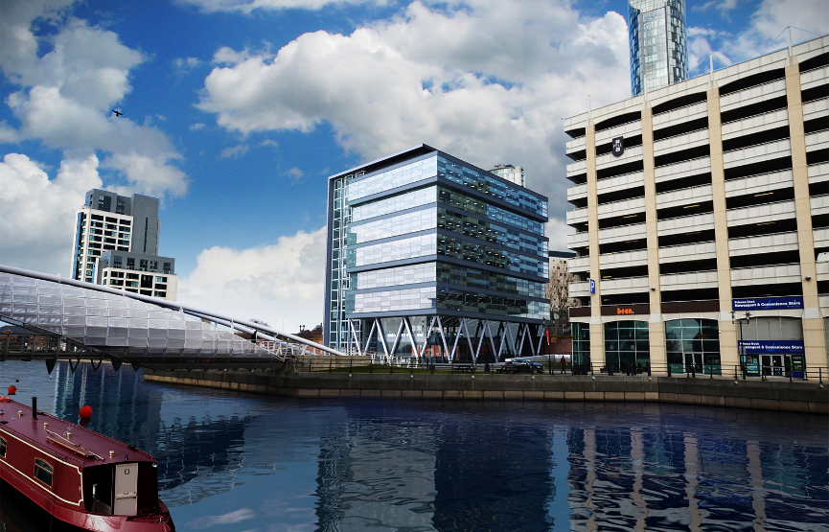

Figure 2: Proposed commercial development

## 2.3 Cruise Liner Terminal

Maintaining Liverpool’s famous maritime links is a key requirement for the new development. For this reason, a new Cruise Liner terminal has been proposed to be able to serve ships carrying up to 3,600 passengers. This new 2-storey terminal will offer its own passport control area, as well as other features such as a 59-car capacity short stay car park (680m2), taxi rank, and passenger lounge. The new Cruise Liner terminal will sit on a deck suspended above the river Mersey. The remainder of the Princes Landing Stage will need to be removed, and a 90m link span bridge is to be built. The total height of the building will be 10m, requiring 1500m2 of glass panelling. Initial plans predict the total floor area as 8,572 m2.

You should factor the following approximated time scales into your project planning:

* It takes **3 weeks** to excavate the foundations.
* It takes **5 weeks** to lay the concrete.
* It takes **5 weeks** to construct the walls.
* It takes **3 weeks** to add the roof.
* It takes **2 weeks** to add the windows.
* It takes **2 weeks** to do the plumbing for the building.
* It takes **4 weeks** to install electrical supply.
* It takes **1 week** to add the insulation to the building.
* It takes **3 weeks** to decorate the building.
* The first stage involves surveying the bedrock on which the new Cruise Terminal will sit. This will take **4 weeks.**
* Removing the remainder of Princes Landing Stage will take **2 weeks.**
* The carpark will **4 weeks** to build.
* The link bridge takes **5 weeks** to build.
* Building the internal furniture and features, such as coffee shops and check in, will take **1 week** in total.

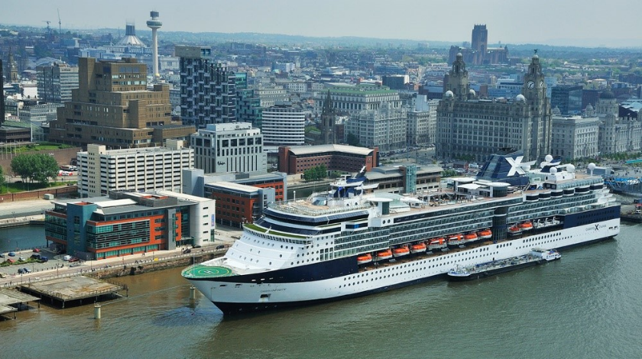

Figure 3: Proposed Cruise Liner Terminal

## 2.4 Isle of Man Ferry Terminal

Not only is a new Cruise Liner terminal being built on site, £3.5 million has been secured for a new Isle of Man ferry terminal. The new site is being shifted from the Pier Head, to Prince’s Half Tide Dock. The initial plans for the Isle of Man Ferry Terminal define the size of the building as 1,600 m2, with a height of 6m. Similar to the existing ferry terminal, the building will double up as a cafe and a restaurant extending its use beyond a ferry terminal. To accommodate passengers with cars, there will be a 60-car capacity short stay car park. The terminal building internals should be aesthetically pleasing to passengers whilst they wait.

You should factor the following approximated time scales into your project planning:

* It takes **1.5 weeks** to excavate the foundations.
* It takes **2 weeks** to lay the concrete.
* It takes **2 weeks** to construct the walls.
* It takes **1.5 weeks** to add the roof.
* It takes **1 week** to add the windows.
* It takes **2 weeks** to do the plumbing for the building.
* It takes **2 weeks** to install electrical supply.
* It takes **1 week** to add the insulation to the building.
* It takes **2 weeks** to decorate the building.
* Adding the internal furniture and features, such as cafe and a restaurant will take **2 weeks** in total.
* Adding security features takes **1 week** in total.
* Adding check in facilities will take **1 week** in total.

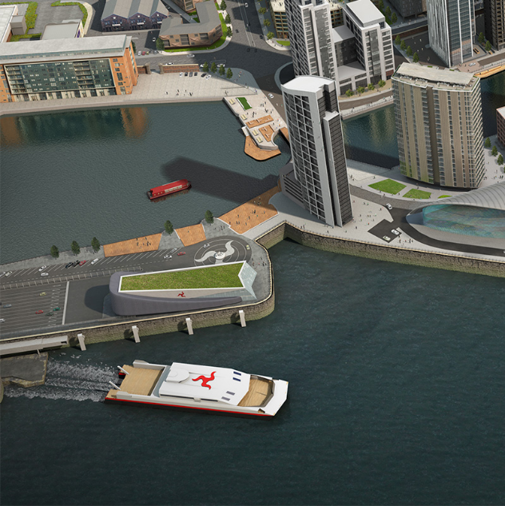

Figure 4: Proposed Isle of Man ferry terminal

## 2.5 5 Star Hotels

The existing hotels are inadequate to fulfil demands of the number of guests visiting the city. For a five star hotel main elements are location, spacing, classes and available facilities (lobby, meeting rooms, conference and exhibition halls, bar etc.). The new four hotels should not exceed 12 storey height (~36m) and be 70 metres in length and 25 metres in width. Your job is to build a suitable hotels that must have a reception, lobby, bar, conference rooms and various class bedrooms for the hotel guests that should follow the following requirements:

You should factor the following approximated time scales into your project planning:

* It takes **2 weeks** to excavate the foundations.
* It takes **3 weeks** to lay the concrete.
* It takes **4 weeks** to construct the walls.
* It takes **2 weeks** to add the roof.
* It takes **3 weeks** to add the windows.
* It takes **3.5 weeks** to do the plumbing for the building.
* It takes **3 weeks** to install electrical supply.
* It takes **2 weeks** to add the insulation to the building.
* It takes **3 weeks** to decorate the building.
* Adding the internal furniture and features, such as the reception, lobby and conference rooms will take **2 weeks** in total.
* It will take **4 days** to install 1 back-up generator
* Furnishing the bedrooms and fitting necessary installation takes **2.5 weeks** to install.
* Adding the elevators to the building takes **1 week** in total.

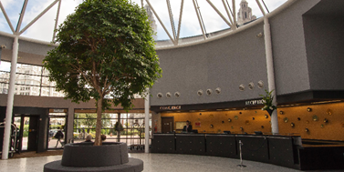

Figure 5: Proposed 5 star hotel reception

## 2.6 Bars & Restaurants

Liverpool Water project will contain Bars & Restaurants to provide a unique and relaxing dining experience for its guests and visitors by providing menu items incorporating quality ingredients at reasonable prices. **Your job** is to build a four moderately priced 50 seat restaurants offering family style food and service following these requirements:

You should factor the following approximated time scales into your project planning:

* It takes **1 week** to excavate the foundations.
* It takes **2 weeks** to lay the concrete.
* It takes **2 weeks** to construct the walls.
* It takes **1.5 week** to add the roof.
* It takes **1 week** to add the windows.
* It takes **1.5 weeks** to do the plumbing for the building.
* It takes **2.5 weeks** to install electrical supply.
* It takes **1 week** to add the insulation to the building.
* It takes **2.5 weeks** to decorate the building.
* Adding the internal furniture and features, such as the kitchen and dining area, will take **2 weeks** in total.
* Installing air conditioning units will take **3 days.**
* Furnishing the restaurant will take **2.5 weeks** in install.

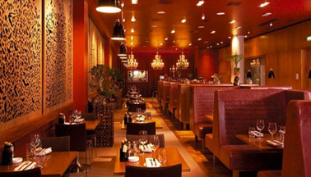

Figure 6: One of the four restaurants

## 2.7 World Class Sports Stadium

Everton FC plan to build a new stadium at Bramley Moore dock on the banks of the River Mersey. The club has announced a funding deal with Liverpool Council and has agreed to buy the land from Peel. The club will also consult fans on stadium design and capacity, as well as other details.

**Your Job**

Your job is to build a state of the art stadium for Everton Football Club. The stadium should have a capacity of 55,000 spectators, and should therefore have the facilities and transport links to accommodate for this amount of people. The grass pitch has dimensions 100m x 68m. The stadium will mainly be made from a combination of steel and concrete. It can be required that 80,000 m3 of concrete and 20,000 tonnes of steel are required in the construction of this stadium. The stadium should be 50m high, 250m long and 220m wide.

You should factor the following approximated time scales into your project planning:

* It takes **4 weeks** to excavate the foundations.
* It takes **6 weeks** to lay the concrete.
* It takes **6 weeks** to construct the walls.
* It takes **4 weeks** to add the roof.
* It takes **3 weeks** to add the windows.
* It takes **3 weeks** to do the plumbing for the building.
* It takes **4 weeks** to install electrical supply.
* It takes **2 weeks** to add the insulation to the building.
* It takes **4 weeks** to decorate the building.
* The football pitch and watering systems will take **2 weeks** to install.
* The seats within the stadium will take **3 weeks** to install.
* Building the internal furniture and features, such as boxes, bars and toilets, will take **3 weeks** in total.
* Screens and digital equipment will take **2 weeks** to install.

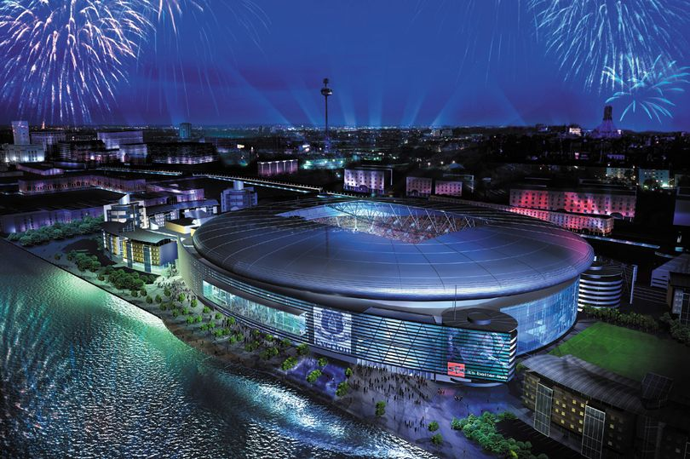

Figure 7: Proposed Everton FC stadium

## 2.8 Retail Park

The Liverpool waters project plans to include a 10,000m2 retail park that offers local residents with a wide and varied choice of shopping. The park will be located near the Prince’s Jetty, so that it is in close proximity to the multi-storey car park.

The retail park will consist of three individual hybrid units spanning around the perimeter of the park, each unit housing 5 small stores. The dimensions of each hybrid unit is 10m in height, 20m in depth and 80m in width. Each store is of equal size with a width of 16m. The units will mainly consist of concrete and steel for the structure, and glass for the storefronts. Each store requires electricity, a water supply and air conditioning. The construction of the retail park should follow the below requirements:

You should factor the following approximated time scales into your project planning:

* It takes **3 weeks** to excavate the foundations.
* It takes **3 weeks** to lay the concrete.
* It takes **4 weeks** to construct the walls.
* It takes **3 weeks** to add the roof.
* It takes **2.5 weeks** to add the windows.
* It takes **2 weeks** to do the plumbing for the building.
* It takes **3 weeks** to install electrical supply.
* It takes **1 week** to add the insulation to the building.
* It takes **2 weeks** to decorate the building.
* Building the internal furniture and features, such as storage shelving, display units and cash counters will take **2 weeks** in total.
* Adding security features takes **1 week** in total.
* Carpark lighting will take **2 weeks** to install.

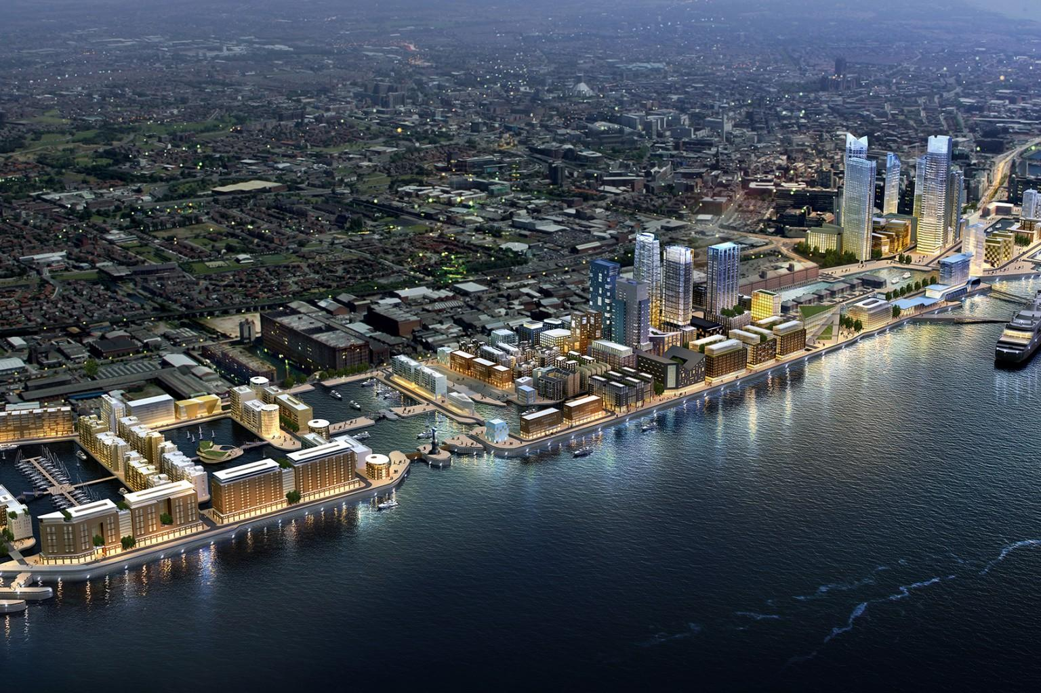

Figure 8: Proposed retail park

## 2.9 Sports & Leisure Centre

To give a varied experience of city life, it is important to incorporate leisure facilities into the development. It is your job to produce a large Sports and Leisure centre for over 1000 people who live in the apartments on the Liverpool Waterfront. It needs to contain an Olympic size swimming pool, a large gym and other leisure facilities such as; spa, tennis courts and squash courts. The sports and leisure centre should be 20m high, 100m long and 60m wide.

You should factor the following approximated time scales into your project planning:

* It takes **2 weeks** to excavate the foundations.
* It takes **2 weeks** to lay the concrete.
* It takes **2.5 weeks** to construct the walls.
* It takes **2 weeks** to add the roof.
* It takes **1 week** to add the windows.
* It takes **2 weeks** to do the plumbing for the building.
* It takes **3 weeks** to install electrical supply.
* It takes **1 week** to add the insulation to the building.
* It takes **2.5 weeks** to decorate the building.
* The swimming pool will take **2 weeks** to install.
* The flooring of the internal sports courts will take will take **1 week** to lay.
* Gym equipment will take **1 week** to install.

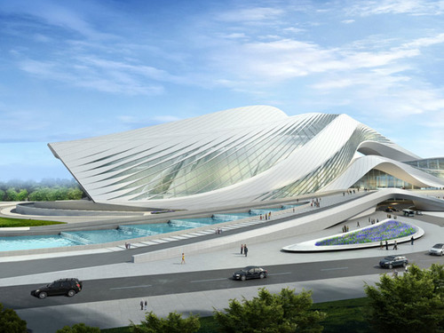

Figure 9: Proposed sports and leisure centre

## 2.10 Supermarket

It is expected that the Liverpool Waters will become a highly visited area once completed therefore a supermarket will need to be built to accommodate this. The supermarket should be able to capacitate 25000 people per week, with dimensions of 60m length, 20m width and 5m height. It will mainly consist of concrete and steel for the structure, and glass for the storefront. The supermarket requires electricity, a water supply, refrigeration units and air conditioning systems.

You should factor the following approximated time scales into your project planning:

* It takes **1.5 weeks** to excavate the foundations.
* It takes **2 weeks** to lay the concrete.
* It takes **2 weeks** to construct the walls.
* It takes **1 week** to add the roof.
* It takes **1 week** to add the windows.
* It takes **2 weeks** to do the plumbing for the building.
* It takes **2.5 weeks** to install electrical supply.
* It takes **1.5 weeks** to add the insulation to the building.
* It takes **2 weeks** to decorate the building.
* Refrigeration units takes **4 days** to install.
* Air conditioning system takes **4 days** to install.
* Roller shutters take **2 days** to install.
* Adding the internal furniture and features, such as shelving units and till registers, will take **2 weeks** in total.

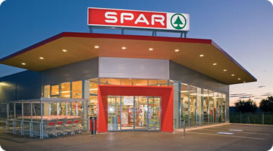

Figure 10: Proposed Supermarket

# Further Information

* 1. Tools and Materials

The tools and materials available for each project are included within the table below. It is up to you to decide which of these tools and materials are required for your allocated construction project:

|  |  |  |  |  |
| --- | --- | --- | --- | --- |
| **Machinery** | **Materials** | **Services** | **Interior** | **Exterior** |
|
| Tower crane | Wood | Plumbing | Furniture | Plants |
| Excavator | Sand | Electricity | Check-in desks | Doors, windows and fittings |
| Cement mixer | Paint | Drainage | Security equipment | Exterior glass panels |
| Digger | Wood | Water supply | Information boards | Kitchen appliances and cookery, bar equipment |
| Loader | Cement |  | Kitchen equipment | Furnishings of dining rooms and bars |
| Pumps | Glass Panels |  | Air conditioning system | Refrigeration Units |
| Compressors | Steel reinforced concrete |  | Lounge/ shop equipment | Grass |
| Lorries | Silicon sealant |  | Interior decorations | Bedrock surveyors |
| Acetylene torch | Floor tiles |  |  |  |
| Dumpers | Glass |  |  |  |
|  | Roof tiles |  |  |  |
|  | Tarmac |  |  |  |
|  | Bricks |  |  |  |
|  | Structural steelwork |  |  |  |
|  | Soil |  |  |  |
|  | Concrete |  |  |  |